Comp 150VIZ – Lab 5 – Tyler Lubeck, Ben deButts, Susi Kharraz-Post

**Comparison of different visualizations**

We chose to compare two versions of bar charts, with bars running horizontal and bars running vertical, pie charts, stacked bar charts and squarified tree maps with regards to how well subjects were able to judge the size of the smaller as a percentage of the larger. The averaged results are as follows:

|  |  |  |
| --- | --- | --- |
| **Visualization** | **Average Error** | **Standard Error on Error** |
| Bar Chart (horizontal) | 1.3226 | 0.22 |
| Bar Chart (vertical) | 1.3505 | 0.23 |
| Pie Chart | 1.7468 | 0.18 |
| Tree Map | 2.1101 | 0.20 |
| Stacked Bar Chart | 2.3367 | 0.22 |

We were expecting the two bar charts to show different performance because we expected a difference in judging width versus judging height, but those two visualizations performed very similarly. We also expected the stacked bar chart to outperform both the pie chart and the tree map because it does not involve an angle and at least one of the dimensions is constant.

Sample images for the above visualizations:

 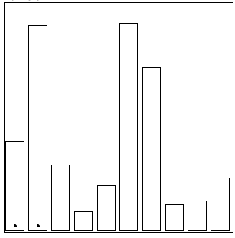

Figure 1 – Bar Chart (horizontal) Figure 2 – Bar Chart (vertical)

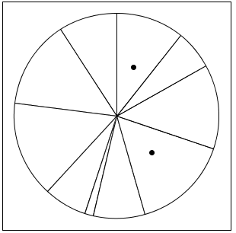 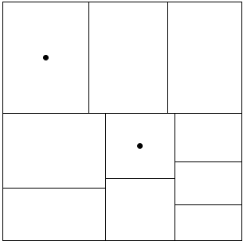

Figure 3 – Pie Chart Figure 4 – Tree Map

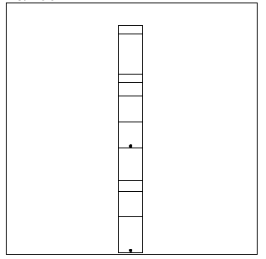

Figure 5 – Stacked Bar Chart